Weird Model Attempt 1:

Trying to predict location based on only time and animal type. As you can see the results are horrible. Time was divided into two section, the day, out of 365 of the timestamp and the year itself hot encoded. I would have preferred hot encoding the days as well but my memory capacity limits me in that regard.

Model: Two layer LSTM model with size 512 and two fully connected layers. End loss was about 8.

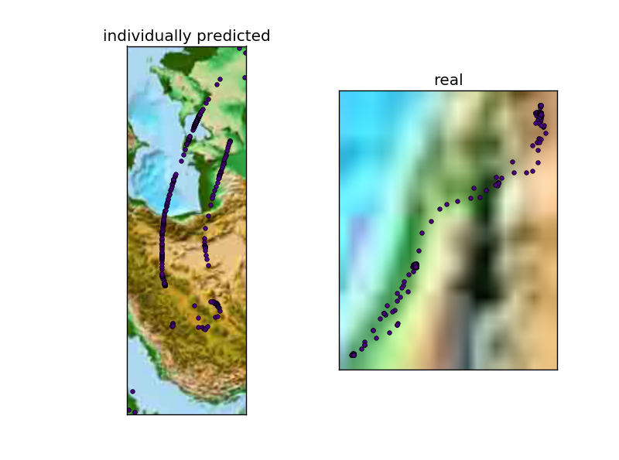

So it’s completely off and in fact for some of the predictions manages to go beyond 90+ or 90- longitude/lattitude.

Model 2

Autogressive model + days in year, animal type and years hot encoding.

The auto encoding is the average of the past N values. This allows us to deal with minute variation instead of responding every single change. We hope this smoothes out the model more.

First Attempt used an autoregressive model with 10 average long/lat. Trained on a 2 level layers RNN.

It went out of bounds for all test set. Hence, results were horrifyingly bad.